19.42: (a) 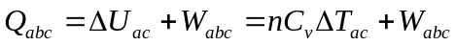
get 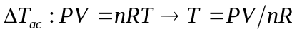

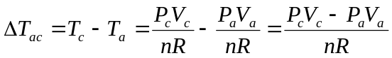
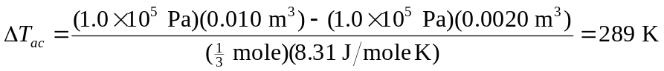
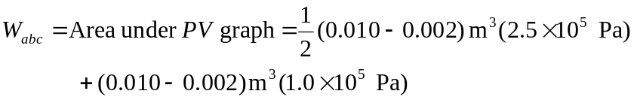
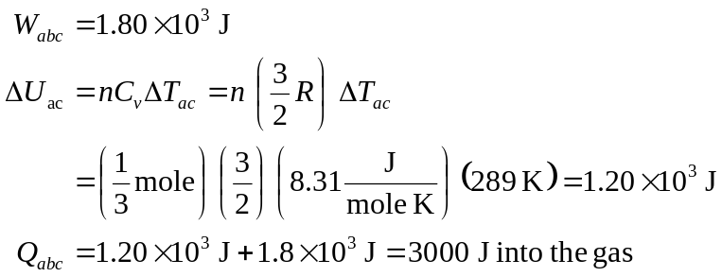

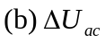in the same = 1200 J

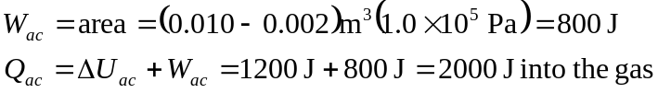

(c) More heat is transfered in abc than in ac because more work is done in abc.

